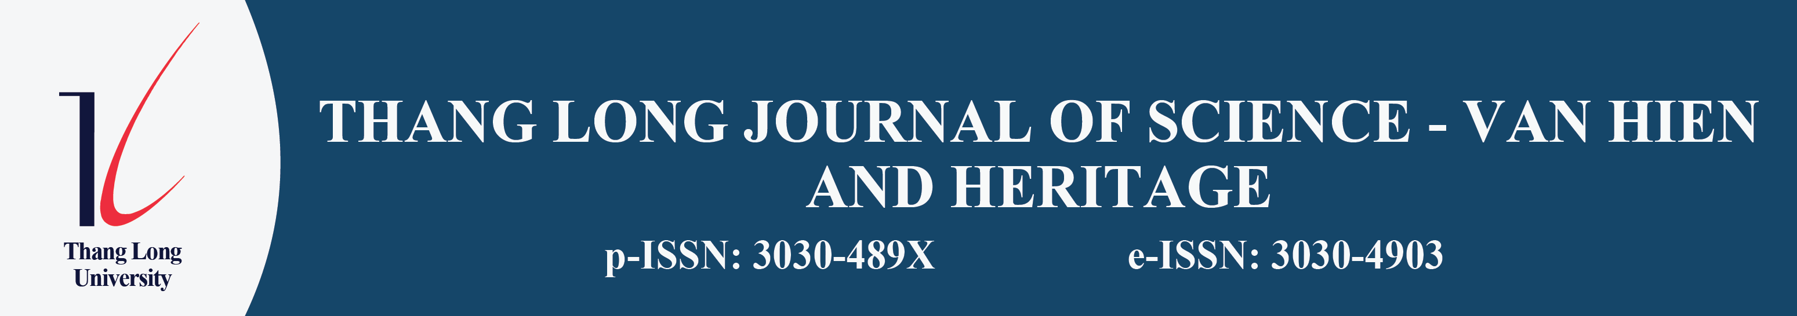

DECLARATION OF AUTHORSHIP, CONFLICT OF INTEREST
AND FUNDING SOURCES
Phiếu tuyên bố quyền tác giả, xung đột lợi ích và nguồn tài trợ
After completing the manuscript submission, the corresponding author is kindly requested to read and confirm the contents below before sending the article to the Journal.
Article title: ........................................................................................
Corresponding author: ..............................................................................
Email: ..................................................................................................
Telephone: ..........................................................................................
Affiliation: ............................................................................................
List of authors: ......................................................................................
............................................................................................................
1. DECLARATION OF AUTHORSHIP
The corresponding author, on behalf of the group of authors, confirms that:
The article is a work carried out by the authors, has never been published, and is not under consideration at any other journal, proceedings, publisher, or publishing organization.
All authors named in the article have made academic contributions to the work, have read the manuscript, and agree with the content of the article.
The order of the authors' names in the article has been agreed upon by all authors.
The content of the article is truthful and does not violate ethical standards in research and publishing.
The article contains no plagiarism, self-plagiarism, data fabrication, data falsification, or unauthorized use of the work of others.
The tables, images, data, quotations, and references in the article are used appropriately, have clear origins, and comply with academic citation regulations.
The group of authors agrees to allow the Journal to review, peer-review, edit, archive, and publish the article in accordance with the Journal's publishing process if the article is accepted for publication.
The group of authors commits to cooperating with the Journal during the peer review, revision, and publication process and in handling any issues arising in relation to the article, if any.
2. DECLARATION OF CONFLICT OF INTEREST
The corresponding author confirms that the group of authors has declared the factors that may relate to conflicts of interest of the article, including financial interests, personal relationships, professional relationships, organizational relationships, or other factors that may affect the objectivity of the work.
Please select one of the following two options:
The group of authors has no conflict of interest related to this article.
The group of authors has a conflict of interest to declare.
Content of the declaration, if any:
............................................................................................................
............................................................................................................
............................................................................................................
3. FUNDING SOURCES
Please select one of the following two options:
This article/research did not receive any funding.
This article/research received funding.
Name of the funding organization/individual, if any:
............................................................................................................
Code of the research topic/project, if any:
............................................................................................................
Role of the funding organization, if any:
............................................................................................................
............................................................................................................
Other information related to the funding source, if any:
............................................................................................................
............................................................................................................
4. USE OF AI AND ASSISTIVE TECHNOLOGIES
The authors confirm that AI tools, if used, only played a supporting role in the manuscript preparation process and are not credited as authors. The group of authors takes full responsibility for the accuracy, truthfulness, and integrity of the content of the article.
Please select one of the following two options:
The article did not use AI or assistive technologies in the manuscript preparation process.
The article used AI or assistive technologies.
Name of the tool and purpose of use, if any:
............................................................................................................
............................................................................................................
............................................................................................................
Full name of the corresponding author:  ................................................  Date of confirmation: ……. / ……. / …………. | Author's signature  (Sign and write full name)  ........................................

